

on

“**FINITE DIFFERENCE APPROXIMATIONS OF PARTIAL DIFFERENTIAL EQUATIONS”**

**Prepared for:**

**MR. JAI SINGH MAURYA**

**Prepared by: group-1**

**ABHINAV KUMAR CHOUDHARY (21SCSE1011615)**

**ABHIJEET KUMAR MISHRA**

**ADARSH KUMAR RAM**

TABLE OF CONTENTS

* 1. Introduction…………………………………………………………………………………………… 3
  2. Steps of finite difference solution ……………………………………………………………. 4
  3. Rectangular Grid…………………………………………………………………………………… 5
  4. Finite Difference Scheme……………………………………………………………………… 6
  5. Types Of Approximation………………………………………………………………………… 7
  6. End…………………………………………………………………………………………………………10

## FINITE DIFFERENCE APPROXIMATIONS OF PARTIAL DIFFERENTIAL EQUATIONS

**Introduction**

In general real life EM problems cannot be solved by using the analytical methods, because:

1. The PDE is not linear,
2. The solution region is complex,
3. The boundary conditions are of mixed types,
4. The boundary conditions are time dependent,
5. The medium is inhomogeneous or anisotropic.

For such complicated problems numerical methods must be employed. The basic approach for solving PDE numerically is to transform the continuous equations into discrete equations, which can be solved using a computational algorithm to obtain an approximate solution of the PDE.

Finite Difference Method (FDM) is one of the available numerical methods which can easily be applied to solve PDE’s with such complexity.

FD method is based upon the discretization of differential equations by finite difference equations.

Finite difference approximations *have algebraic forms* and relate the value of the dependent variable at a point in the solution region, to the values at some neighboring points. It is easy to understand and apply.

## Steps of finite difference solution:

* Divide the solution region into a grid of nodes or list of points spanning the computational domain,
* Approximate the given differential equation by finite difference equivalent,
* Apply a source or excitation,
* Solve the differential equations subject to the boundary conditions.

When the PDE includes time as an independent variable, the FD approach is referred as the finite difference time-domain (FDTD) algorithm.

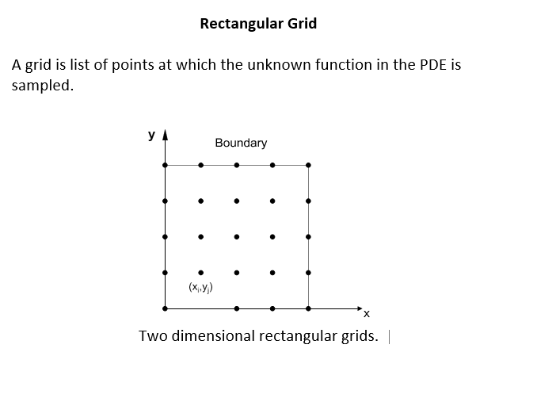

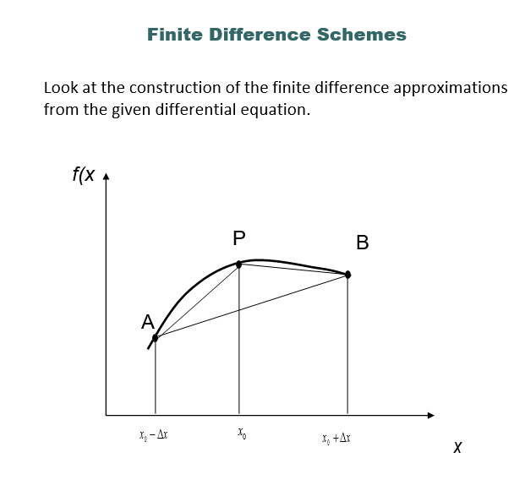

The derivative of a given function f(x) can be approximated in different ways. Higher order approximations can be used to obtain more accurate results by using many sample values at neighboring points. But higher order approximations increase the computational cost.

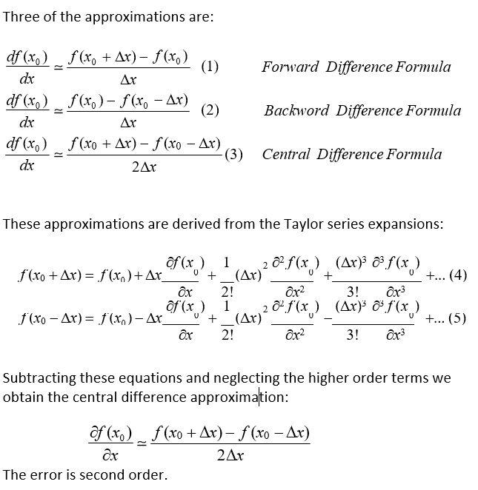

The error in the forward and backward approximation formulas is first order.

As long as the derivatives of *f* are well behaved and the step size is not too large, the central difference formula is more accurate compared to the other two. i.e. backward and forward difference approximations.

The error in central difference decreases quadratically as the step size decreases, whereas the decrease is only linear for the other two formulas.

In general, central difference formula is to be preferred. Situations where the data is not available on both sides of the point where the numerical derivative is to be calculated are exceptions.

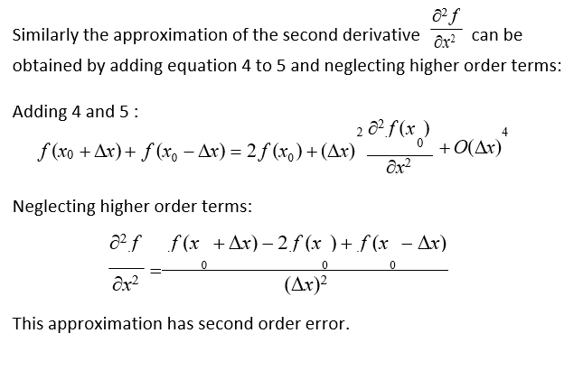

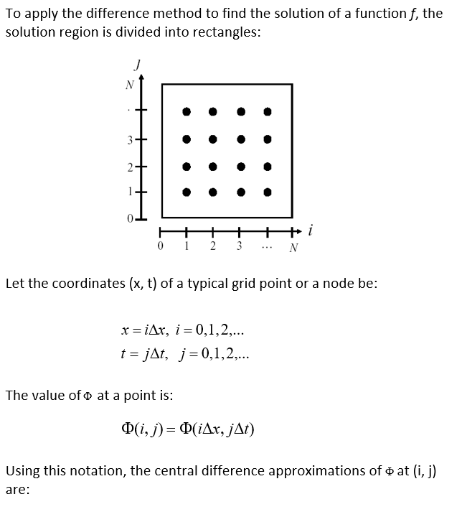

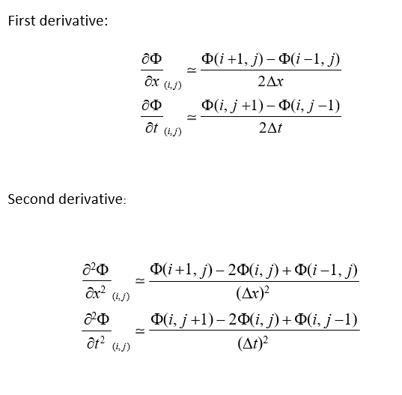

**END**